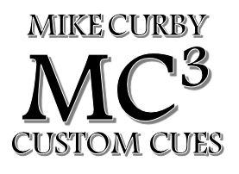

MC³ SHAFT ORDER FORM
DATE: Click or tap to enter a date.
FIRST NAME: Click or tap here to enter text. LAST NAME: Click or tap here to enter text.
EMAIL: Click or tap here to enter text.
PRICES: Carbon Fiber shooter $375, Carbon fiber break $350, Kielwood $325, Maple $200, Purpleheart $225

MATERIAL: ☐Carbon Fiber Shooter ☐Carbon Fiber Break ☐Kielwood ☐Maple ☐Purpleheart
LENGTH: ☐29” ☐30” ☐Other Click or tap here to enter text.
FERRULE LENGTH: ☐3/16” ☐1/2”
☐1” ☐Other Click or tap here to enter text.
FERRULE COLOR: ☐White ☐Black ☐Brown
JOINT PIN: Click or tap here to enter text.
JOINT DIAMTER: Click or tap here to enter text.
TIP: Click or tap here to enter text.
JOINT COLLAR: ☐Standard ½” Black Juma ☐Other Click or tap here to enter text.
RINGSTACK: ** Click or tap here to enter text.

**Ringwork is an additional charge. Can match most ringwork

